Detecting Fraud Signals in Centers for Medicare & Medicaid Service Data

Love Ayinde, Narsim Kamath, Cameron T. Kass, Member, IEEE, and Sabrina Woo

Abstract— Fraud is a pervasive and complex problem within the United States healthcare system necessitating increasingly robust detection methods. Our approach uses an analytical framework that integrates Centers for Medicare & Medicaid Services (CMS) Open Payments data, CMS Durable Medical Equipment, Prosthetic Devices, Prosthetics, Orthotics, & Supplies (DMEPOS) program utilization data, and the Department of Health and Human Services Office of Inspector General’s (OIG) List of Excluded Individuals/Entities into a standardized dataset from which we extract interpretable, specialty-level fraud risk signals for participating providers in Missouri and bordering states during calendar years 2021 through 2023. We apply an explainable hybrid model pipeline using Isolated Nearest Neighbor Ensemble (INNE) and XGBoost to determine baseline “normal” behavior across our focused population, then flag providers who have a higher estimated likelihood of fraud risk without needing to utilize large numbers of confirmed fraud labels. For transparency, the score is paired with top contributing anomaly factors, enabling faster, more consistent investigative prioritization. The final model delivered a 50x lift over the fraud prevalence baseline and maintained a 10% confirmed fraud hit rate among the top 100 flagged providers. We cross-reference our results with Missouri’s list of active Medicaid providers to identify overlaps with high-risk providers participating in the Medicare DMEPOS program and integrate our findings into an interactive dashboard equipped with an agentic AI Model Context Protocol framework that accesses OIG and Missouri Secretary of State websites to improve the Missouri Medicaid Fraud Control Unit’s ability to access reports, audits, investigations and oversight findings.

Index Terms— Class imbalance, DMEPOS, Fraud Detection, Medicare, XGBoost

I. INTRODUCTION
T
HE The creation of income security and health care programs in the 20th century produced a class of programs that the U.S. Congress formally defines as mandatory or direct spending [1]. A mandatory spending program is a federally funded program which is not funded via annual appropriations bills, and Medicare and Medicaid are examples of mandatory spending programs created to provide individuals with health insurance. Healthcare fraud, waste, and abuse (FWA) drain billions of taxpayer dollars each year and undermine the integrity of these programs, posing a persistent challenge to the U.S. healthcare system. Fiscal year 2025 estimates indicate that improper Medicare Fee-for-Service payments totaled $28.83 billion [2]. One particularly vulnerable area involves Durable Medical Equipment, Prosthetics, Orthotics, and Supplies (DMEPOS), which includes items such as wheelchairs, knee braces, and other medical supplies. According to the Office of Inspector General (OIG), Medicare payments for DMEPOS exceed $7 billion annually, and this category remains “a major concern” for FWA in federal programs [3].
The U.S. legal and enforcement landscape has increasingly prioritized combating FWA, establishing it as a strategic focus of federal healthcare oversight. On June 30, 2025, the U.S. Department of Justice announced the largest healthcare fraud takedown in U.S. history, charging 324 defendants in schemes amounting to $14.6 billion [4]. Although there has been a revitalized focus, FWA investigations rely heavily on public hotline referrals, interagency recommendations, manual audits, and retrospective reviews, which are often slow, resource-intensive, and reactive rather preventive. As a result, fraud prevention efforts remain insufficient to curb its proliferation within the Medicare DMEPOS program aided by emerging technologies. On February 27, 2026, CMS deemed a national moratorium on the enrollment of medical device suppliers into this program necessary to prevent or combat FWA [5].
Medicaid is a state-administered program that is funded jointly by states and the federal government to provide health coverage to low-income adults, children, pregnant women, elderly adults, and people with disabilities [6]. CMS estimates improper payments for Medicaid totaled $37.39 billion during fiscal year 2025 attributing 77.17 percent of which to insufficient documentation [2]. While payments with insufficient documentation are not generally indicative of fraud, they suggest that the program’s payment controls do not effectively safeguard against improper disbursements. Fraudsters have an opportunity to exploit this weakness and potentially receive payments by submitting fraudulent claims. They may choose to target Medicaid and Medicare simultaneously due to the similarities between these programs, and as such, fraud patterns in occurring in one program are reasonably likely to appear in the other. Our work is therefore relevant to Medicaid Fraud Control Units (MFCUs) which are teams of investigators, attorneys, and auditors which typically operate under the Attorney General’s office in each of the 50 States, District of Columbia, Puerto Rico, and the U.S. Virgin Islands to investigate and prosecute Medicaid provider fraud [7].
Our project will explore how data-driven approaches can identify providers whose billing and financial behaviors deviate from expected norms enabling fraud investigators to discover high-risk providers through more efficient automated processes. Using a machine-learning framework to analyze provider-level claims data and manufacturer financial transaction data to identify potential DME-related fraud, we position anti-fraud agencies to stay ahead of emerging AI-driven schemes.

II. Related Works

A. Traditional Fraud Detection and Its Limiations
Traditional fraud detection in healthcare and finance has shifted from manual audits and rule-based checks toward machine learning methods [8]. Of these machine learning approaches, supervised learning relies on labeled fraudulent and non-fraudulent cases to train models that classify future claims or transactions as fraud or normal. Unsupervised learning is commonly used to detect anomalous patterns or identify outliers. The most common supervised models are Random Forest, tree-based models (particularly XGBoost), Logistic Regression, Support Vector Machines (SVM), Naïve Bayes, neural networks, and graph neural networks ([8], [9], [10], [11], [12], [13], [14]). For unsupervised methods, k-means, k-Nearest Neighbors, Local Outlier Factor, PCA, one-class SVM, Isolation Forest, DBSCAN, Isolated Nearest Neighbor Ensemble (INNE), and Empirical-Cumulative-distribution-based Outlier Detection (ECOD) ([8], [9], [10], [14], [15], [16], [17], [18], [19], [20], [21]). In general, supervised learning is the dominant approach in fraud literature in healthcare and finance ([8], [9], [10]). This is then followed by unsupervised methods while hybrid approaches are far less frequent but still implemented within the fraud detection domain ([14], [21], [22], [23]).
The overall limitations of current machine learning approaches in the healthcare and fraud space are like those encountered in rare-event modeling. Fraud data is scarce and expensive to obtain since confirmed fraud cases require investigation or expert validation; this leads to a major class imbalance [8], [9]. Additionally healthcare data is often very complex, text-based, inconsistent, and contain many missing values [9]. Machine learning models applied in fraud can also produce costly misclassifications, especially when false negatives allow fraudulent activity to go undetected or false positives trigger unnecessary investigations [9]. Finally, many methods can be a black box and lack explainability for investigators. These limitations are important to consider before examining how fraud investigations are initiated and carried out operationally.
In general, fraud investigations for private health industries are generally initiated through claims analytics, algorithms, or audits [8]. Alternatively, fraud investigations for MFCUs are generally kickstarted by hotline tips, interagency referrals, and federal investigations ([24], [25]). Current investigation methods at the state level are held up by bureaucracy and budget restraints. Specifically, for MFCUS’s, budgets of the team are dependent on federal allocations and are subject to regulatory limits tied to state Medicaid program expenditures. [25]. As a result, while private health industries may rely on higher staff numbers and high-tech detection systems, MFCUs face structural obstacles for fraud investigations.
These barriers are not limited to just resources; they also extend to the adoption of newer technologies. State and local governments have been slow to adopt Artificial Intelligence (AI) software or tools due to explainability concerns, lack of trained staff, and institutional pressures [26]. However, pilot cases of AI uses have been shown to improve the work efficiency of administrative teams [27]. Primarily, these cases have involved generative AI usage for legal research, document search, analytical reporting, and document processing [28], [29]. AI assistants, or AI tools that are able to perform basic tasks given the role of the user, have also been known to show efficiency gains and streamline task completion [29].

B. Similar Work
Two studies conduct a comprehensive survey of the state of healthcare fraud detection research. Du Preez et al. [8] conducted a systematic literature review of machine learning approaches used in health insurance fraud detection, examining data sources and methodologies reported over the past 20 years highlighting key challenges in the field, available datasets, methodologies, and opportunities for future research. Li et. al. [9] provide a comprehensive survey of statistical methods for healthcare fraud detection, examining both supervised and unsupervised approaches to identifying fraudulent behaviors in medical data. The paper categorizes supervised methods, which require labeled datasets of known fraud cases, including techniques such as neural networks, decision trees, and Bayesian networks, as well as unsupervised methods, which detect anomalies or outliers without pre-labeled data, using clustering and anomaly detection algorithms.
The authors Bauder and Khoshgoftaar have conducted extensive machine-learning studies using Medicare data to perform fraud detection. Khoshgoftaar co-authored a 2023 publication [13] on leveraging CMS data for Medicare Part B, Part D, and DMEPOS programs during the 2013 – 2019 program years to perform fraud classification with XGBoost and random forest. Bauder and Khoshgoftaar jointly published a 2018 study using random forest models while investigating how class imbalance in Medicare big data affects fraud detection [14]. They applied random under sampling to create seven different class distributions (From 99.9:0.1 to 50:50) and test random forest performance finding their model trained on the distribution of 90:10 (non-fraud: fraud cases) achieved the best AUC score.
Tajrobehkar et al. [12] explored the use of machine learning to improve Medicare fraud detection specifically targeting overutilization schemes in which providers manipulate claim documents to obtain larger payments from Medicare than they are entitled to. The authors sought to overcome the limitations of traditional methods that rely heavily on LEIE datasets and manual audits, arguing that this approach tends to ignore subtle patterns and fixates only on extreme cases. They tested multiple machine learning models, such as K-nearest neighbor (KNN), logistic regression (LR), support vector machines (SVM), extreme gradient boosting (XGB), and multilayer perceptron (MLP). However, the scalability of the authors’ approach is highly limited, as they rely on a small, expertly-curated datasets which would require labor-intensive expert-labeling to scale to the vast array of specialties spanned by Medicare providers. Their models also generally fail to distinguish legitimate overutilization from actual fraud.
Bairy et al. [30] focused on detecting healthcare fraud using unsupervised learning methods. They apply techniques such as Isolation Forest, Local Outlier Factor (LOF), kNN-based outlier detection, and autoencoders to identify anomalous billing and provider behaviors, comparing which approaches most effectively flag suspicious patterns. Liu and Vasarhelyi [31] utilized an unsupervised clustering model that incorporates geo-location data. Using claims-level data purchased from CMS, their models calculated the distance between the providers and the beneficiaries to identify unusual patterns, such as patients travelling large distances for service. They then clustered the providers and claims based on the geography and service patterns to highlight outliers without requiring labeled data.
Hamid et al. [21] addressed the challenge of healthcare insurance fraud detection by designing a hybrid two-stage pipeline that combines association rule mining with unsupervised anomaly detection. Using the Apriori algorithm, they first extracted frequent patterns in claims, then applied methods such as Isolation Forest, Cluster Based Local Outlier Factor (CBLO), Ensemble Correlation-Based Outlier Detection (ECOD), and One-Class SVM to flag usual behaviors. Using the Silhouette score, they found that CBLOF and Isolation Forest were the best performing models.
Sethi [32] focused on the broader concept of risk scoring in healthcare analytics, particularly how machine learning models can assign quantitative risk scores to entities such as patients, providers, and clinical processes to predict high-risk outcomes. The score was determined by integrating multiple predictive features from historical and real-time data, which may include billing patterns, claim volumes, and frequency of high-cost services, unusual service combinations, prior sanctions or exclusions (like in the LEIE database), and regional socioeconomic indicators. The model calculated an overall risk score for each provider, usually scaled between 0 and 1 or 0 and 100, where higher scores indicated a higher likelihood of fraudulent or anomalous behavior.
Kaddi and Patil [33] addressed the challenges of detecting fraud in healthcare claims within imbalanced datasets. Due to the evolving nature of fraudulent schemes, standard rule-based fraud detection methods are ineffective. Therefore, the authors proposed an ensemble learning approach utilizing a stack ensemble learning model which combines multiple base classifiers to improve accuracy. Given the extremely small proportion of fraud cases, the authors employed Synthetic Minority Over-sampling Technique (SMOTE) to balance the dataset and improve performance. The performance of the model was compared with individual classifiers, and the experiment showed that the ensemble learning approach significantly outperforms the rest.
El-Lanky and Chrimes [34] presented a big data analytics approach to detecting fraud in U.S. Medicare claims, emphasizing how the massive scale of healthcare service data can be effectively processed to uncover irregular billing and provider behaviors. They address the challenges of big data by leveraging parallel computing and distributed frameworks such as Hadoop and Spark to handle millions of claims efficiently, while also reducing complexity through feature engineering that aggregates raw claims into provider-and-service-level metrics. This not only makes the data computationally manageable but also highlights patterns that are meaningful for fraud detection across large and diverse populations.
Hancock et al. [18] proposed a feature reduction methodology for Medicare fraud detection. Their novel ensemble approach combined CatBoost, XGBoost, Random Forest, Extremely Randomized Trees, LightGBM, and Decision Tree classifiers to produce a ranked list of features based on median rank by built-in feature importance values across all models. They then performed ANOVA and HSD to find the minimum number of features for selection.

C. Feature Engineering
Previous studies demonstrated that engineering features based on domain knowledge of specific fraud schemes, rather than using generic features, significantly improve outlier detection in healthcare claims data [19]. Fortunately, our data comes in a unified format, which also prevents patient identity from being exposed through re-identification.
Kumaraswamy et al. [35] introduced a feature engineering framework employing statistical standardization techniques including z-score normalization, mean, and standard deviation to quantify deviations in billing behavior across providers.
Herland et al. [36] established data imputation as a required preprocessing step for handling missingness in CMS Medicare data, incorporating it within a pipeline that transformed records from the procedure level to the provider level through aggregation. Johnson et al. [13] later expanded this framework with explicit, domain-guided strategies: missing provider genders were assigned a third category “U" for unknown and suppressed beneficiary count fields were imputed with a value of 5, reflecting CMS's practice of leaving counts below 10 blanks for privacy reasons.

D. Class Imbalance Challenges
Across our datasets, fraudulent providers represent an extremely small fraction of all observations, a condition that Fernández et al.[37] confirmed causes standard classifiers to default toward the majority class, often resulting in deceptively high accuracy scores while completely failing to identify the minority class.
This portion of the literature broadly identifies two data level strategies for addressing class imbalance: oversampling, which adds volume to the minority class, and undersampling, which reduces the majority class. Hida et al. [38] provide an overview of both strategies across multiple reviewed studies, highlighting that most researchers opt for a combination of both rather than relying on either alone, reflecting the recognition that no single approach is sufficient on its own. Additionally, Fujiwara et al. [39] demonstrates that when the minority class is extremely small in absolute count, combining both approaches consistently outperforms either strategy used alone, and their proposed method achieved meaningful improvements in AUC scores over undersampling-only-methods in such conditions.
SMOTE, the most widely used oversampling technique, generates synthetic minority samples by creating new examples based on the characteristics of existing minority instances, and Fujiwara et al. [39] notes that it can improve classifier sensitivity when used thoughtfully. However, Fernández et al. [37] found that SMOTE degrades significantly at scale, as it relies on finding nearby data points to generate new synthetic samples, but when the data is extremely large and spread across many categories, those nearby points may no longer be truly close to each other, making the synthetic samples it creates less meaningful.
Beyond scalability considerations, undersampling better preserves the true nature of fraud as a rare event rather than artificially inflating it, which matters for the interpretability and credibility of our results. Herland et al. [40] directly supports this decision in a Medicare fraud context, noting that less balanced sampling ratios consistently outperformed more balanced ones. Interestingly, it further highlighted the 50/50 balanced ratio performing the worst, since removing too many majority class instances prevented the model from adequately learning what non-fraudulent behavior looks like, which itself carries useful discriminative information.
Bhattacharya et al. [41] laid the groundwork for smart cluster-based undersampling methods by proposing an iterative approach where K-means clustering is first used to group the majority class, and the resulting centroids are continuously refined based on which majority samples are most confusing to the classifier at each iteration, progressively improving the quality of the majority class representation. Building on this cluster aware philosophy, Bach et al. [42] proposed CLEANSE, which takes a more structured approach by distinguishing between homogeneous majority clusters and mixed clusters. In the homogeneous majority clusters, only the most redundant samples closest to the centroid are removed, while in mixed clusters, KNN is used to identify and remove majority class samples sitting closest to the decision boundary.
Both methods share the same core principle that not all majority samples carry equal informational value, and that removing the right ones leads to a better trained classifier compared to removing them randomly. Moreover, both papers report strong performance gains on highly imbalanced datasets using their respective approaches.

III. Data
This project utilizes only publicly available datasets released by U.S. federal. All the data was directly accessed from official government websites at no cost and without restricted access.
The Centers for Medicare and Medicaid Services (CMS) have data published for 2021 to 2023 calendar years of the Part B non-institutional Durable Medical Equipment, Prosthetic Devices, Prosthetics, Orthotics, & Supplies (DMEPOS) claims for Medicare fee-for-service beneficiaries. It contains aggregated information at the National Provider Identifier (NPI) level capturing key billing metrics such as submitted charges, Medicare allowed amounts, and total payments. In addition, CMS publishes payments data [43] as mandated under the Physician Payments Sunshine Act [44], covering financial relationships between drug and medical device manufacturers and their covered recipients from 2021 to 2023. As a means of representing a positive fraud class, this project uses the Office of Inspector General (OIG) List of Excluded Entities and Individuals (LEIE) [45]. This list identifies all individuals and entities currently excluded from federally funded health care programs due to reasons that may include criminal convictions for Medicare or Medicaid fraud, patient abuse, license revocation and related offenses. The list reflects all active exclusions as of September 10th, 2025, with records dating back to July 1st, 1977. It is important to note that this list is biased towards national criminal convictions and underrepresents or excludes any civil settlements or other private legal actions; in addition, some providers may have their licenses reinstated or continue practicing despite convictions [14].
The data used does not include patient-level identifiable data used at any stage. CMS suppressed provider and supplier records involving 10 or fewer unique beneficiaries prior to data release to ensure privacy protection. Additionally, financial relationships captured in the Open Payments data were treated as supporting indicators rather than an indicator of wrongdoing, which is consistent with CMS’s published guidance on the program.
The CMS aggregates DMEPOS claims data by referring provider [46] and by supplier [47] as well as by referring provider and service [48] and by supplier and service [49] for each program year. We obtained each dataset as three CSV files corresponding to the program years under consideration. The original by referring provider dataset Carpentry performed on datasets with both levels of aggregation including manually appending labels for the program year and imputing null values. Fields in which missing values were deemed appropriate (such as middle initial or second line of street address) were left unmodified. Null credential records were replaced by an empty string, and text normalization to lowercase and remove punctuation was performed. Missing values for total supplier beneficiaries were imputed as five following the methodology of Khoshgoftaar & Johnson [13].

IV. Experimental Design
Data Sources & Integration
↓
Feature Engineering
↓
Unsupervised Learning
↓
Supervised Learning
↓
Model Training & Testing
↓
Evaluation & Output

All datasets were unified to a provider–year analytical unit using the NPI as the common linking key, enabling consistent joins across CMS DMEPOS claims, Open Payments manufacturer-to-provider financial transactions, and the OIG LEIE exclusion list. Two parallel model-ready datasets were maintained throughout: one for referring providers and one for billing suppliers. Providers were labeled as fraudulent or non-fraudulent by joining the LEIE.
Feature engineering was applied to both datasets, constructing specialty-group z-scores for billing amounts and claim frequencies, year-over-year temporal change features, allowed amount ratios relative to HCPCS-level national averages, and payment type flags derived from AI-assisted text normalization of Open Payments product category fields. All z-scores were computed within specialty cohorts rather than globally to ensure anomaly signals reflect meaningful peer-group deviation.
The data was split into a 60% training and 40% test set using stratified, NPI-grouped partitioning to prevent provider-level leakage. Feature selection was performed using SelectKBest applied across importance scores from XGBoost, CatBoost, and Decision Tree classifiers, with k=100 features selected based on AUPRC maximization across 5-fold StratifiedGroupKFold cross-validation. Random under sampling was applied to address the extreme class imbalance, with fraud labels representing less than 0.15% of all provider-year records across geographic subsets.
Prior to the supervised stage, unsupervised anomaly detection was conducted on the Open Payments dataset using INNE to surface atypical manufacturer-to-provider financial relationships. The three supervised classifiers were evaluated: XGBoost, Logistic Regression, and SVM, model performance was assessed using AUPRC as the primary metric, with Macro F1, AUC-ROC, Macro Precision, Macro Recall, and Precision@K (K=100) as secondary metrics.

V. RESULTS AND DISCUSSION
Due to the extreme class imbalance present in the dataset, fraud labels represent less than 0.07% of the data. Given such an imbalance, traditional classification accuracy is not a meaningful evaluation metric. The study, therefore, employs AUPRC, Macro Precision, and Precision@K as the primary measures of model performance.
Prior to the supervised pipeline, an unsupervised anomaly detection stage was conducted using three models – Empirical Cumulative Distribution-based Outlier Detection (ECOD), Isolation Forest, and Isolation using Nearest Neighbor Ensemble (INNE). These three models were chosen for their algorithmic diversity, their demonstrated use in health fraud and payment anomaly detection literature and for their computational efficiency on large datasets. Each model was assessed using AUPRC as the primary metric alongside the Mann-Whitney test. Results showed that INNE outperformed the alternative models, achieving the highest AUPRC score of 0.0012. Despite INNE’s strong performance, its derived features did not improve cross-validation scores when integrated into the supervised pipeline and as a result, were not included in the final model configuration.
Iterative experimentation across multiple model families, undersampling strategies and feature selection methods was conducted to identify the best supervised model. Logistic Regression served as a strong baseline but exhibited severe instability across folds, while SVM flagged approximately 84% of all normal providers as fraudulent on the test set, rendering it impractical for investigative use. XGBoost with LightGBM SelectKBest feature selection (k=100) and Random Undersampling not only provided an acceptably high AUPRC of 0.2385 but also had the lowest standard deviation across all runs, offering the most consistent generalization performance.

Figure 1: Precision-Recall Curve (Final Model)
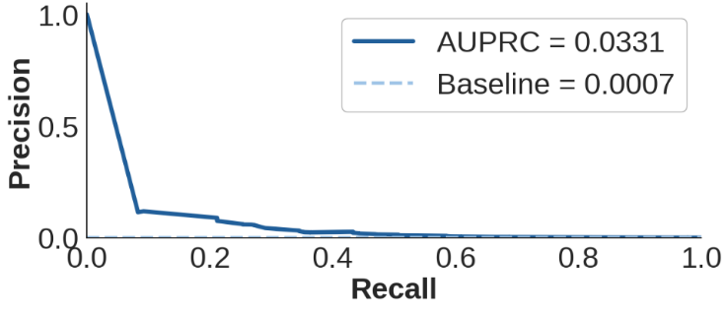
The final model achieved a Macro Precision of 0.5161, Macro Recall of 0.6694, Macro F1 of 0.5280, AUPRC of 0.0331, and AUC-ROC of 0.8818 on the test set. The AUPRC, while low in absolute terms, represents a 50x improvement over the fraud prevalence baseline of 0.00066. However, the most meaningful measure for this system is Precision@K, as shown in Figure 1.
Figure 2: Precision@K Results (XGBoost)
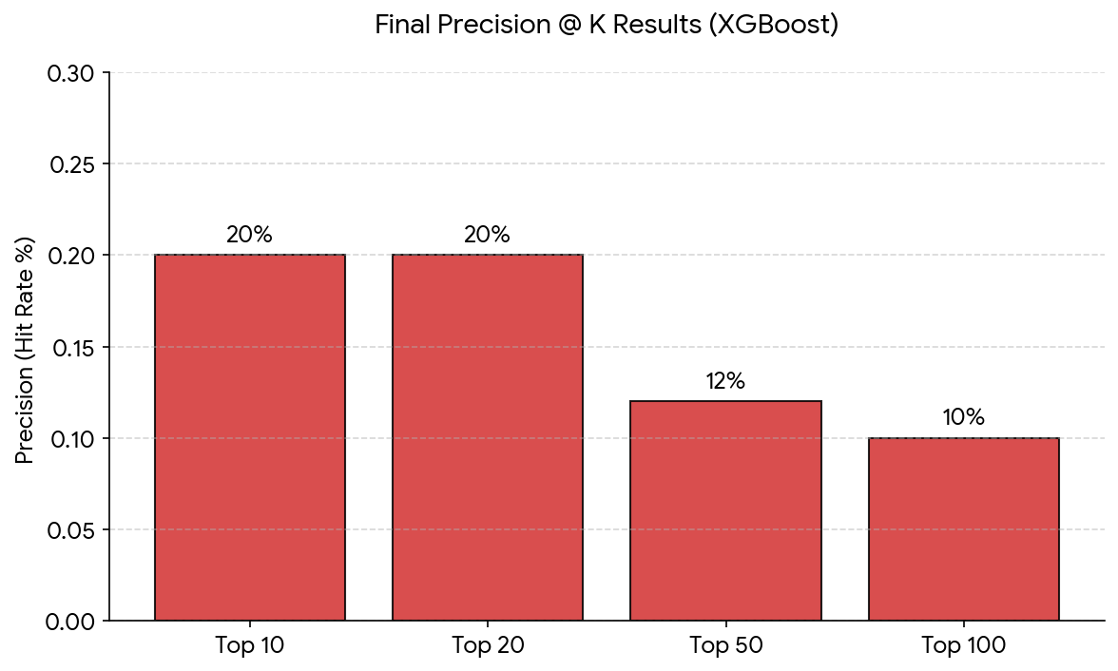
A consistent 20% hit rate was achieved across the top 20 providers, declining to 10% at the top 100, confirming the model is successfully concentrating known fraud at the top of its output.
To understand the drivers of these predictions, SHAP analysis was conducted. It was revealed that Services per Beneficiary was the single most dominant predictor, followed by Third Party Recipient Sum. An unexpected finding was the presence of missing data flags, specifically for Claims per Beneficiary and Submitted Charges per Beneficiary, among the top 10 features, suggesting that the missing data itself carries predictive power and may reflect irregular billing behavior.
To produce an operationally actionable output, predicted probabilities were converted into four percentile-based risk tiers: Low, Medium, High and Critical.
Figure 3: Risk Score Category
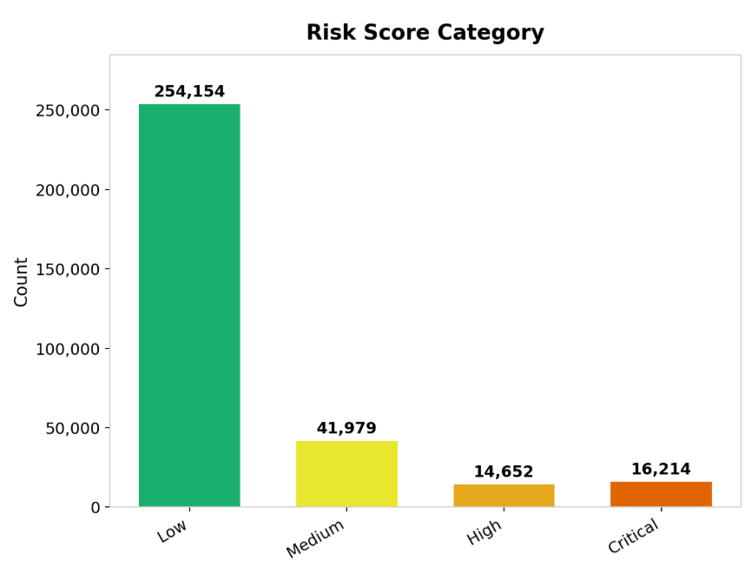As shown in Figure 2, the vast majority fall in the Low and Medium tiers, while a much smaller proportion are classified as High or Critical. The Critical tier in particular represents a highly condensed shortlist of high-risk providers, drastically reducing the number of cases investigators need to review. Of the top 100 providers, all of which fall within the Critical tier, 10 were confirmed fraud cases, directly validating the effectiveness of the stratification as an investigative triage tool.

VI. Conclusion
The results of this project confirm that machine learning can detect healthcare fraud risk from publicly available data. The final model delivered a 50x lift over the fraud prevalence baseline and maintained a 10% confirmed fraud hit rate among the top 100 flagged providers. While the unsupervised anomaly detection did not improve any of the approaches when integrated, it did identify INNE as the best performing model and provided valuable context on manufacturer payment anomalies.
The Missouri state fraud investigation experts have acknowledged that capturing all fraud is neither realistic nor expected. Therefore, the value of the project lies in the system’s ability to narrow down an unmanageable pool of providers into a prioritized shortlist that is backed by evidence, in turn, providing the investigators with a credible starting point that previously did not exist.
As an overall limitation, the resulting project used a granularity of data that is not industry standard and generally harder for machine learning to discern signals. Further research should pursue this pipeline using a higher granularity dataset like the CMS Limited Data Sets for Researchers. Our approach was focused on DME; however, similar works have integrated CMS Part A and CMS National Plan and Provider Enumeration System public data. Specifically, discussions with fraud experts indicated that future work should include NPI deactivation dates and additional provider addresses to the data. Considering that fraud is an extremely rare event, future works using less aggregated data may perform at higher marks.

References and Footnotes

Acknowledgment
The authors thank the Missouri Medicaid Audit and Compliance team, including Director Richard Ferrari, Darla Weekley, Colin Murdick, and Jeffrey Rex, for providing fraud expertise. The team thanks Director Arvids Petersons of the Missouri Medicaid Fraud Control Unit for consistently supporting the project and providing subject matter expertise. Special thanks to Dr. Ilker Ersoy and Dr. Timothy Haithcoat for training and advising the project team.
References
[1] “Distinguishing Between Discretionary and Mandatory Spending | Congress.gov | Library of Congress.” Accessed: May 06, 2026. [Online]. Available: https://www.congress.gov/crs-product/IF13124
[2] “Fiscal Year 2025 Improper Payments Fact Sheet | CMS.” Accessed: May 05, 2026. [Online]. Available: https://www.cms.gov/newsroom/fact-sheets/fiscal-year-2025-improper-payments-fact-sheet
[3] “Durable Medical Equipment Fraud and Safeguards in Medicare,” Office of Inspector General | Government Oversight | U.S. Department of Health and Human Services. Accessed: May 02, 2026. [Online]. Available: https://oig.hhs.gov/reports/work-plan/browse-work-plan-projects/durable-medical-equipment-fraud-and-safeguards-in-medicare/
[4] “Office of Public Affairs | National Health Care Fraud Takedown Results in 324 Defendants Charged in Connection with Over $14.6 Billion in Alleged Fraud | United States Department of Justice.” Accessed: May 02, 2026. [Online]. Available: https://www.justice.gov/opa/pr/national-health-care-fraud-takedown-results-324-defendants-charged-connection-over-146
[5] “Medicare, Medicaid, and Children’s Health Insurance Programs: Announcement of Nationwide Temporary Moratoria on Enrollment of Durable Medical Equipment, Prosthetics, Orthotics, and Supplies (DMEPOS) Supplier Medical Supply Companies,” Federal Register. Accessed: May 02, 2026. [Online]. Available: https://www.federalregister.gov/documents/2026/02/27/2026-03971/medicare-medicaid-and-childrens-health-insurance-programs-announcement-of-nationwide-temporary
[6] “Medicaid | Medicaid.” Accessed: May 05, 2026. [Online]. Available: https://www.medicaid.gov/medicaid
[7] “Medicaid Fraud Control Units,” Office of Inspector General | Government Oversight | U.S. Department of Health and Human Services. Accessed: May 06, 2026. [Online]. Available: https://oig.hhs.gov/fraud/medicaid-fraud-control-units-mfcu/
[8] A. Du Preez, S. Bhattacharya, P. Beling, and E. Bowen, “Fraud detection in healthcare claims using machine learning: A systematic review,” Artificial Intelligence in Medicine, vol. 160, p. 103061, Feb. 2025, doi: 10.1016/j.artmed.2024.103061.
[9] J. Li, K.-Y. Huang, J. Jin, and J. Shi, “A survey on statistical methods for health care fraud detection,” Health Care Manage Sci, vol. 11, no. 3, pp. 275–287, Sep. 2008, doi: 10.1007/s10729-007-9045-4.
[10] L. Hernandez Aros, L. X. Bustamante Molano, F. Gutierrez-Portela, J. J. Moreno Hernandez, and M. S. Rodríguez Barrero, “Financial fraud detection through the application of machine learning techniques: a literature review,” Humanit Soc Sci Commun, vol. 11, no. 1, pp. 1–22, Sep. 2024, doi: 10.1057/s41599-024-03606-0.
[11] Z. Bolukbasi, H. Yurtoglu, E. Kugu, and H. Cukurtepe, “Insurance Fraud Detection Using Machine Learning and XAI Algorithms,” in 2025 IEEE International Conference on Electro Information Technology (eIT), Valparaiso, IN, USA: IEEE, May 2025, pp. 463–468. doi: 10.1109/eIT64391.2025.11103653.
[12] M. Tajrobehkar et al., “Utilization Analysis and Fraud Detection in Medicare via Machine Learning,” Jan. 01, 2025, medRxiv. doi: 10.1101/2024.12.30.24319784.
[13] J. M. Johnson and T. M. Khoshgoftaar, “Data-Centric AI for Healthcare Fraud Detection,” SN COMPUT. SCI., vol. 4, no. 4, p. 389, May 2023, doi: 10.1007/s42979-023-01809-x.
[14] R. Bauder and T. Khoshgoftaar, “Medicare Fraud Detection Using Random Forest with Class Imbalanced Big Data,” in 2018 IEEE International Conference on Information Reuse and Integration (IRI), Jul. 2018, pp. 80–87. doi: 10.1109/IRI.2018.00019.
[15] H. De Meulemeester, F. De Smet, J. Van Dorst, E. Derroitte, and B. De Moor, “Explainable unsupervised anomaly detection for healthcare insurance data,” BMC Med Inform Decis Mak, vol. 25, no. 1, p. 14, Jan. 2025, doi: 10.1186/s12911-024-02823-6.
[16] T. R. Bandaragoda, K. M. Ting, D. Albrecht, F. T. Liu, Y. Zhu, and J. R. Wells, “Isolation‐based anomaly detection using nearest‐neighbor ensembles,” Computational Intelligence, vol. 34, no. 4, pp. 968–998, Nov. 2018, doi: 10.1111/coin.12156.
[17] H. Xiang et al., “OptIForest: Optimal Isolation Forest for Anomaly Detection,” Jun. 23, 2023, arXiv: arXiv:2306.12703. doi: 10.48550/arXiv.2306.12703.
[18] J. T. Hancock, R. A. Bauder, H. Wang, and T. M. Khoshgoftaar, “Explainable machine learning models for Medicare fraud detection,” J Big Data, vol. 10, no. 1, p. 154, Oct. 2023, doi: 10.1186/s40537-023-00821-5.
[19] F. T. Liu, K. M. Ting, and Z.-H. Zhou, “Isolation Forest,” in 2008 Eighth IEEE International Conference on Data Mining, 2008, pp. 413–422. doi: 10.1109/ICDM.2008.17.
[20] Z. Li, Y. Zhao, X. Hu, N. Botta, C. Ionescu, and G. H. Chen, “ECOD: Unsupervised Outlier Detection Using Empirical Cumulative Distribution Functions,” IEEE Trans. Knowl. Data Eng., vol. 35, no. 12, pp. 12181–12193, Dec. 2023, doi: 10.1109/TKDE.2022.3159580.
[21] Z. Hamid, F. Khalique, S. Mahmood, A. Daud, A. Bukhari, and B. Alshemaimri, “Healthcare insurance fraud detection using data mining,” BMC Medical Informatics and Decision Making, vol. 24, no. 1, p. 112, Apr. 2024, doi: 10.1186/s12911-024-02512-4.
[22] R. Bauder, R. Da Rosa, and T. Khoshgoftaar, “Identifying Medicare Provider Fraud with Unsupervised Machine Learning,” in 2018 IEEE International Conference on Information Reuse and Integration (IRI), Salt Lake City, UT: IEEE, Jul. 2018, pp. 285–292. doi: 10.1109/IRI.2018.00051.
[23] F. Carcillo, Y.-A. Le Borgne, O. Caelen, Y. Kessaci, F. Oblé, and G. Bontempi, “Combining unsupervised and supervised learning in credit card fraud detection,” Information Sciences, vol. 557, pp. 317–331, May 2021, doi: 10.1016/j.ins.2019.05.042.
[24] Office of Inspector General, “Medicare Fraud Strike Force,” Office of Inspector General. [Online]. Available: https://oig.hhs.gov/fraud/strike-force/
[25] Medicaid Agency Fraud Detection and Investigation Program, vol. 42. 1987. [Online]. Available: https://www.ecfr.gov/current/title-42/chapter-IV/subchapter-C/part-455/subpart-A
[26] S. Hatz, N. Dreksler, K. Wei, and B. Zhang, “Local US officials’ views on the impacts and governance of AI: Evidence from 2022 and 2023 survey waves,” 2025, arXiv. doi: 10.48550/ARXIV.2501.09606.
[27] D. Ruediger, R. MacDougall, S. Brachfield, D. Dechow, J. Parker, and J. Remy, “AI Adoption in Research Administration at Emerging Research Institutions,” Ithaka S+R, Mar. 2026. doi: 10.18665/sr.325252.
[28] M. Overton, B. Robison, and L. Sheneman, “TaMPERing with Large Language Models: A Field Guide for using Generative AI in Public Administration Research,” 2025, arXiv. doi: 10.48550/ARXIV.2504.01037.
[29] Umut Turgut YILDIRIM1* and Sena ŞAHİN2, “UNDERSTANDING THE MOTIVATIONS BEHIND ARTIFICIAL INTELLIGENCE (AI) ADOPTION IN LOCAL GOVERNMENTS: A QUALITATIVE STUDY OF POLITICIANS AND MANAGERS,” Mar. 2026, doi: 10.5281/ZENODO.18916705.
[30] M. Bairy, B. Muniyal, and N. P. Shetty, “Enhancing healthcare data integrity: fraud detection using unsupervised learning techniques,” International Journal of Computers and Applications, vol. 46, no. 11, pp. 1006–1019, Nov. 2024, doi: 10.1080/1206212X.2024.2408262.
[31] Q. Liu and M. Vasarhelyi, “Healthcare fraud detection: A survey and a clustering model incorporating Geo-location information,” 2013.
[32] USA and S. Sethi, “Risk Scoring Models in Healthcare Data Analytics: A Practitioner’s Perspective on Machine Learning, Interpretability, and Regulatory Compliance,” Prog Med Sci, pp. 1–4, Feb. 2025, doi: 10.47363/PMS/2025(9)E173.
[33] S. S. Kaddi and M. M. Patil, “Ensemble learning based health care claim fraud detection in an imbalance data environment,” Indonesian Journal of Electrical Engineering and Computer Science, vol. 32, no. 3, pp. 1686–1694, Dec. 2023, doi: 10.11591/ijeecs.v32.i3.pp1686-1694.
[34] M. El-Lakany and D. Chrimes, “Big data analytic of US Medicare Claims of healthcare service informatics and billing fraud,” in 2024 IEEE International Conference on Big Data (BigData), Dec. 2024, pp. 4013–4022. doi: 10.1109/BigData62323.2024.10825957.
[35] N. Kumaraswamy, M. K. Markey, J. C. Barner, and K. Rascati, “Feature engineering to detect fraud using healthcare claims data,” Expert Systems with Applications, vol. 210, p. 118433, Dec. 2022, doi: 10.1016/j.eswa.2022.118433.
[36] M. Herland, T. M. Khoshgoftaar, and R. A. Bauder, “Big Data fraud detection using multiple medicare data sources,” J Big Data, vol. 5, no. 1, p. 29, Dec. 2018, doi: 10.1186/s40537-018-0138-3.
[37] A. Fernández, S. del Río, N. V. Chawla, and F. Herrera, “An insight into imbalanced Big Data classification: outcomes and challenges,” Complex Intell. Syst., vol. 3, no. 2, pp. 105–120, Jun. 2017, doi: 10.1007/s40747-017-0037-9.
[38] G. S. Hida and A. C. Alves Do Nascimento, “Overview of machine learning in class imbalance scenarios: Trends, challenges, and approaches,” Expert Systems with Applications, vol. 298, p. 129592, Mar. 2026, doi: 10.1016/j.eswa.2025.129592.
[39] K. Fujiwara et al., “Over- and Under-sampling Approach for Extremely Imbalanced and Small Minority Data Problem in Health Record Analysis,” Front Public Health, vol. 8, p. 178, May 2020, doi: 10.3389/fpubh.2020.00178.
[40] M. Herland, R. A. Bauder, and T. M. Khoshgoftaar, “The effects of class rarity on the evaluation of supervised healthcare fraud detection models,” J Big Data, vol. 6, no. 1, p. 21, Dec. 2019, doi: 10.1186/s40537-019-0181-8.
[41] R. Bhattacharya, R. De, A. Chakraborty, and R. Sarkar, “Clustering Based Undersampling for Effective Learning from Imbalanced Data: An Iterative Approach,” SN COMPUT. SCI., vol. 5, no. 4, p. 386, Apr. 2024, doi: 10.1007/s42979-024-02717-4.
[42] M. Bach, P. Trofimiak, D. Kostrzewa, and A. Werner, “CLEANSE – Cluster-based Undersampling Method,” Procedia Computer Science, vol. 225, pp. 4541–4550, Jan. 2023, doi: 10.1016/j.procs.2023.10.452.
[43] Centers for Medicare & Medicaid Services, “General Payment Data – Detailed Dataset.” Jan. 27, 2026. [XSLX]. Available: openpaymentsdata.cms.gov
[44] United States Congress, “Physician Payments Sunshine Act of 2009.” Jan. 22, 2009. Accessed: May 14, 2026. [Online]. Available: https://www.congress.gov/bill/111th-congress/senate-bill/301/text
[45] U.S. Department of Health and Human Services, Office of Inspector General, “List of Excluded Individuals/Entities (LEIE) Database and Supplement Downloads.” Accessed: Oct. 03, 2025. [CSV]. Available: https://oig.hhs.gov/exclusions/leie-database-supplement-downloads/
[46] “Medicare Durable Medical Equipment by Referring Provider | CMS Data.” Accessed: May 13, 2026. [Online]. Available: https://data.cms.gov/provider-summary-by-type-of-service/medicare-durable-medical-equipment-devices-supplies/medicare-durable-medical-equipment-devices-supplies-by-referring-provider
[47] “Medicare Durable Medical Equipment by Supplier Data | CMS Data.” Accessed: May 13, 2026. [Online]. Available: https://data.cms.gov/provider-summary-by-type-of-service/medicare-durable-medical-equipment-devices-supplies/medicare-durable-medical-equipment-devices-supplies-by-supplier
[48] “Medicare Durable Medical Equipment by Provider & Service Data | CMS Data.” Accessed: May 13, 2026. [Online]. Available: https://data.cms.gov/provider-summary-by-type-of-service/medicare-durable-medical-equipment-devices-supplies/medicare-durable-medical-equipment-devices-supplies-by-referring-provider-and-service
[49] “Medicare Durable Medical Equipment by Supplier & Service Data | CMS Data.” Accessed: May 13, 2026. [Online]. Available: https://data.cms.gov/provider-summary-by-type-of-service/medicare-durable-medical-equipment-devices-supplies/medicare-durable-medical-equipment-devices-supplies-by-supplier-and-service

Reflection on the incorporation of a Journal article within the Capstone course:

The value of incorporating a journal article in the capstone course is, in our opinion, highly dependent on the nature of the projects and the audience it is intended for. In the case of our project, the primary stakeholders being investigators from MMAC and MFCU - do not use or refer to any sort of publication or journal article in their workflow. A majority of their findings and communications are shared through membership-restricted professional or government forums that are not accessible to the general public. Therefore, the journal article format does not directly serve the audience this project was built for.

That being said, this exercise still has some value. Writing a journal article for IEEE is a very different challenge when compared to writing a report. It requires the team to be precise, concise and structured , leaving out the unnecessary while ensuring to keep in the information that actually matters. It is honestly a skill that is hard to develop and one that a lot of people struggle with, regardless of how technically strong they are.

Moreover, this program does cover a lot of the technical side of data science, so having a publication as a final deliverable makes sense, and it does help in rounding out that particular skill set. Again, its relevance is completely dependent on the project and its audience, so a rigid one-size-fits all requirement may not always be the right fit.

